Lab Objective

Learn how to Use Administrative Template

**Lab Procedures**

**1.** On RWDC01, using Group Policy Management Editor for GPO7, navigate to and click User Configuration\Policies\Administrative Templates\Desktop\Desktop.

**2.** Double-click Desktop Wallpaper. The Desktop Wallpaper dialog box opens.

**3.** Click Enabled. Then in the Wallpaper Name, type the following:

**C:\Windows\Web\Screen\img101.jpg**

**4.** Take a screen shot of the Desktop Wallpaper dialog box by pressing Alt+Prt Scr and then paste it into your Lab20_worksheet file in the page provided by pressing Ctrl+V.

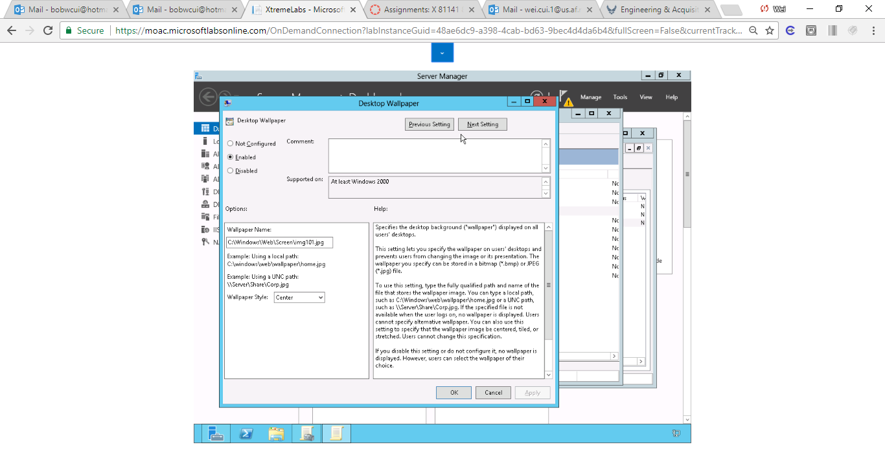

**5.** Click OK to close the Desktop Wallpaper dialog box. The Desktop Wallpaper shows as Enabled.

**6.** Navigate to and click User Configuration\Policies\Administrative Templates\Control Panel\Personalization.

**7.** Double-click Enable screen saver. The Enable screen saver dialog box opens.

**8.** Click Enabled and click OK to close the Enable screen saver dialog box.

**9.** Double-click Force specific screen saver. The Force specific screen saver dialog box opens.

**10.** Click Enabled. In the Screen Saver executable name, type **scrnsave.scr**. Click OK to close the Force specific screen saver.

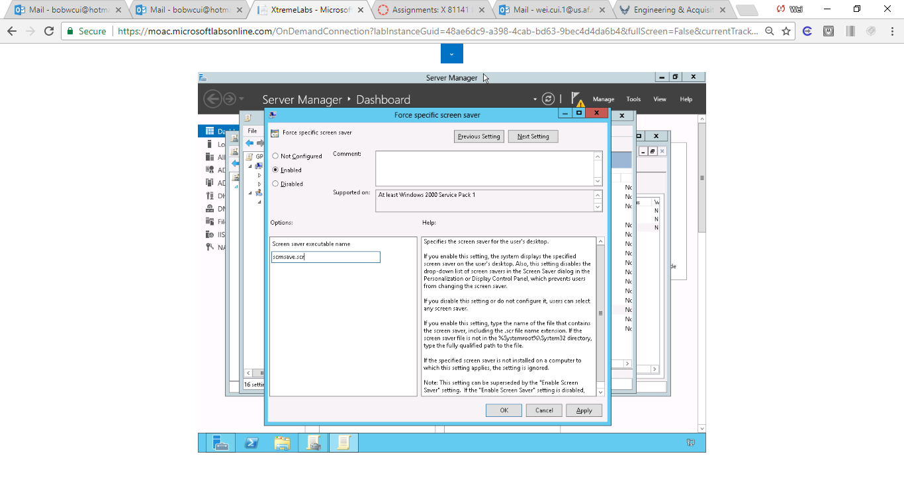

Figure Click Enabled. In the Screen Saver executable name, type scrnsave.scr. Click OK to close the Force specific screen saver

**11.** In the Personalization node, double-clickScreen saver timeout.

**12.** Click Enabled. Answer the following question. Then click OK to close the Screen saver timeout dialog box.

|  |  |
| --- | --- |
| Question 4 | What is the default number of seconds? |

**13.** Lastly, double-click Password protect the screen saver. The Password protect the screen saver dialog box opens.

**14.** Click Enabled. Click OK to close the Password protect the screen saver dialog box.

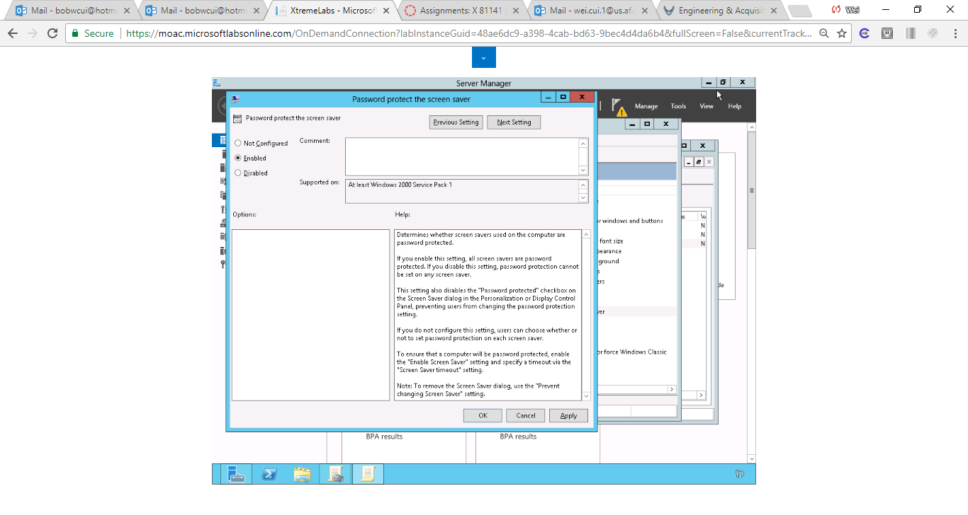

Figure Password protect the screen saver is enabled

**15.** Close the Group Policy Management Editor window.

End of exercise

**Lab Summary**

During this exercise, you configure the desktop wallpaper and screen saver settings. The screen saver settings are used to help protect a system by activating a screen saver when a user walks away from his or her computer for more than 15 minutes. If the screen saver is activated, the user will have to input his or her password to resume.